COMP3111 Activity 1

LI Junrong (20328496)

[jlibz@connect.ust.hk](mailto:jlibz@connect.ust.hk)

Use-case Detailed Specifications for Task 2 & Task 3

**Task 2 - Filter:**

**Brief Description:**

This use case describes how a user(student) can apply the filter on the scrapped courses list.

**Use-case diagram:**

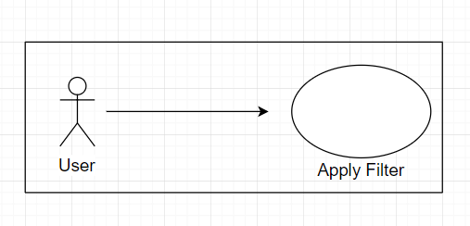

**Basic Flow:**

1. The use case begins when the user chooses the “Filter” tag.

2. The system displays the interface of checking boxes for different filtering conditions.

**{Set Filter Conditions}**

3. The user checks the filter conditions.

3.1 If any checkbox is checked.

**{Filtering}**

3.1.1 If “select all” is checked.

**{Select All}**

3.1.1.1 User clicks “select all” and all boxes are checked.

3.1.1.2 “select all” box changes to “de-select all”.

3.1.2 If “de-select” all is checked.

**{De-Select All}**

3.1.2.1 User clicks “de-select all” and all checkboxes are de-selected.

3.1.2.2 “select all” box changes to “de-select all”.

3.1.3 If a checkbox other than the previous two is selected or deselected.

**{Select/Deselect Something}**

3.1.3.1 User checks a checkbox of filtering condition.

3.1.3.2 The filter conditions are updated.

3.2 Clear the console and display all the filtered information satisfying the conditions.

4. The use case ends.

**Alternative Flows**

***A1: Select All when All Boxes Are Already Selected***

At **{Select All}**, if the user has already manually checked every box.

1. The system changes “select all” box to “de-select all”.

2. The use case ends.

***A2: De-Select All when All Boxes Are Already De-Selected***

At **{De-Select All}**, if the user has already manually unchecked every box.

1. The system changes “de-select all” box to “select all”.

2. The use case ends.

***A3: Course Page Not found***

Before **{Set Filter Conditions}**, if at backend, the course page is not found.

1. The system cannot output anything in the console.

2. The use case ends.

***A4: No Results displayed in the Console***

At **{Set Filter Conditions}**, if there are no results from the filter.

1. The system cannot output anything in the console.

2. The use case ends.

**Task 3 - List:**

**Brief Description:**

This use case describes how a user(student) can change the enrollment status of the course sections.

**Use-case diagram:**

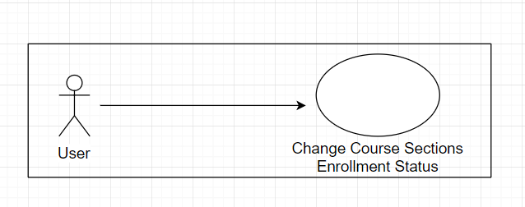

**Basic Flow:**

1. The use case begins when the user chooses the “List” tag.

2. The system fills the list with the results from the “Filter”.

3. The system displays the interface with “Enroll” checkboxes for every piece of courses obtained from “Filter”.

**{Change Enrollment Status}**

4. The user clicks on the Enroll Checkbox

4.1 The status of the Enroll Checkbox is changed.

4.2 The console is cleared.

4.3 Filtered information are displayed in the console.

4.4 The console displays “The following sections are enrolled: ".

4.5 The console prints the list of the enrolled sections.

5. The use case ends.

**Alternative Flows**

***A1: Course Exclusion***

At **{Change Enrollment Status}**, if the user checks a course with an exclusion to a course already enrolled.

1. The system cannot update enrollment status.

2. The use case ends.

***A2: Course Page Not found***

Before **{Change Enrollment Status}**, if at backend, the course page is not found.

1. The system cannot change enrollment status.

2. The use case ends.

***A3: No Results displayed in the List***

At **{Change Enrollment Status}**, if there are no results from the filter.

1. The system cannot change enrollment status.

2. The use case ends.